Gap Year sailing options with Different Drum Sailing Adventures
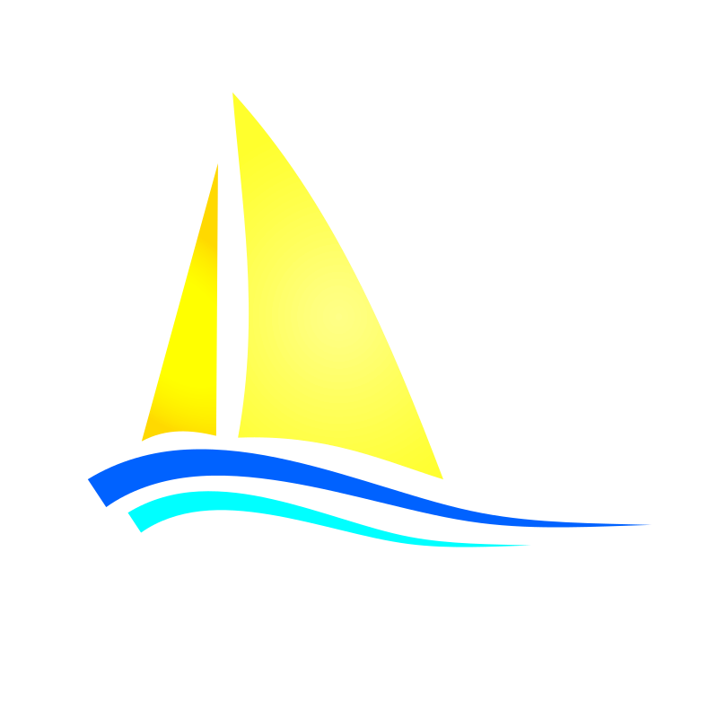
Ready for an incredible summer experience? Join us as we sail from Virginia to Maine! Do you want to sail past the Statue of Liberty, see a Broadway show, walk in Times Square, listen to live music in Central Park, see whales off Cape Cod, hike beaches, spend a day on a Maine lobster boat, and climb to the tops of lighthouses? If so, then come crew aboard the educational sailing vessel Boundless with Capt. Jeff and Different Drum Sailing Adventures!
Choose from two twelve-day adventures or do both for a memorable, 24-day trip of a lifetime!
Trip one begins in Virginia at the Coan River Marina where our vessel Boundless will be docked and waiting for you! From there we’ll sail up the Chesapeake Bay to Baltimore, MD, visiting historic towns along the way. In Baltimore, we’ll go ashore to the Baltimore Aquarium and the Inner Harbor Science Center to catch an IMAX film, and then to Vaccaro’s Italian Pastry Shop! After Baltimore, we’ll sail through the historic Chesapeake/Delaware Canal and down the Delaware Bay, stopping in Lewes, Delaware for the night (and free showers!). Then it’s up the New Jersey Coast and into Atlantic City past the casinos to our anchorage. We’ll go ashore to eat at the world famous “White House Subs” where past presidents, sports figures, and famous actors and musicians have all grabbed a bite to eat.
From Atlantic City, it’s on to New York City for three days of exploring the city. We’ll stroll through Central Park, attend museums, eat in Little Italy, and catch a Broadway Show. On our last day, we’ll say goodbye, unless…you’re joining us for our second trip: NYC to Maine! Virginia to NYC trip dates: June 7-18, 2020
Trip two:
We’ll spend the first two days exploring NYC, including attending a Broadway Show (if you’re lucky enough to combine both trips, you’ll see at least two Broadway Shows!). From NYC to Maine we’ll sail past the Statue of Liberty, under the Brooklyn Bridge, past the United Nations, through the treacherous “Hell’s Gate,” and into Long Island Sound. We’ll spend two days sailing the Sound, anchoring for the night in front of multi-million-dollar, beachfront homes! Then it’s onto Block Island and continued sailing up Buzzard’s Bay to the Woods Hole Oceanographic Research Institute for a tour of its facilities and aquarium.
After Woods Hole, we transit the Cape Cod Canal and onto the Stellwagen Bank National Marine Sanctuary to watch whales feeding and transiting the area. From Cape Cod we sail past Boston, MA, and anchor for the night in Portsmouth, NH, to tour the USS Albacore research submarine. The following day we’ll arrive in our ultimate destination, Portland, Maine! Once there, we’ll have a few days to explore Portland and sail to nearby coastal islands, kayak with seals, and have a traditional Maine lobster bake for dinner. If time allows, we’ll sail to Bath, Maine to visit the Maine Maritime Museum and see U.S. Naval Bath Iron Works where the most high-tech warships are being built! NYC to Maine trip dates: June 20 to July 1, 2020
Gap Year fees include all meals on Boundless, Broadway show tickets, multiple museum/aquarium entrance fees, training and instruction in seamanship, boat operation, sailing techniques, navigation, meteorology, leadership, team building, and all dockage/mooring costs. Personal spending money will be needed for gifts, souvenirs, and occasional meals ashore.
The cost for each twelve-day trip is $1,675 per Gap Year student, plus travel to and from our pick-up/drop-off locations. Combine both trips ($3,350) for a 24 -day sailing adventure!
Space is limited, and we’ll only have room for six Gap Year applicants on each trip. With the combination of sailing plus all the shore side activities, these are memorable, fun, and life changing trips. No previous sailing experience is required, only a desire to learn and a willingness to work with others.

What type of Gap Year student do we look for? We look for fun, happy, flexible, hard-working young adults who love exploring, adventure, the outdoors, and the chance to grow personally through new experiences. People looking to add something to a group experience rather than for what they can get from it, fit in great with us! Flexibility, adaptability, and a sense of humor are key character traits for anyone living aboard a 46’ sailboat and sharing space with as many as nine other people for a week or more at a time. The ability to give others respect always, is essential and valuing another’s space, important. A “me only”, selfish, complaining, or lousy attitude just doesn’t work on board and detracts from everyone’s experience. While you may not be asked to “walk the plank” if you display any of these negative traits, you may be asked to leave and no, you won’t receive a refund!

What will I be required to do aboard Boundless? As a Gap Year student on board Boundless, you are much more than a passenger, you’re crew! In addition to all the fun we’ll have exploring the coast from Virginia to Maine and multiple shoreside activities, you’ll learn how to steer and maintain a compass course, raise anchors and sails, navigate, and keep watch whenever we’re underway. Additional duties may include cleaning and maintaining Boundless daily, meal prep/cooking/after meal clean-up, supervision of non-Gap Year paying guests aboard (students, families, adults), instructing and guiding guests, meeting guests at airports to bring them to Boundless, and learning to operate an inflatable with an outboard engine.
Some weeks may involve just Capt. Jeff and the Gap Year students on board, while other weeks will involve helping to run our educational program for MS and HS teens with guests on board. Amidst all the fun and work, we’re pretty sure you won’t be bored!

Do you want to spend your entire summer living and sailing aboard Boundless, seeing more, doing more, exploring more? We have an additional trip option for people like you…
Optional trip: After our two, twelve-day trips are over, we’ll be hosting several week-long educational sailing adventures aboard Boundless in Maine during July and August and we have room for just one or two Gap Year students to join us as crew! Our July/August trips consist of a teacher along with six of their students from schools we work with on a regular basis. Many of these teachers and students have already sailed Maine or the Bahamas with us sometime in the past. Your duties on board Boundless will be like what you experienced during one of our twelve-day trips, so there won’t be much new to learn, though you will have the opportunity to develop previously learned skills further and will have several more weeks of sailing and exploring Maine with us. A more extensive interview is required as this is a competitive position and for training purposes, your commitment to attend both the twelve-day trips is also required. This is an approximately 5-week commitment that can be met by a single Gap Year student or could be divided between two students if neither can commit to the entire period. Cost is $575 per week. Total cost for approximately 60 days aboard Boundless including the two, 12- day trips plus 5 additional weeks is $6,225 and includes everything from the two 12-day trips and all living expenses including all meals, laundry, admission costs to all events, museums entrance fees, etc. The knowledge and skills you will obtain and have mastery over by the end of the summer, not to mention the self-confidence and life skills learned is enormous and immeasurable. Additionally, all your time spent aboard Boundless may be applied to obtaining a U.S.C.G. Captain’s license in the future. Interested? Contact us to apply!

About us: To learn more about Different Drum Sailing Adventures and who runs the program, visit our web page at differentdrumsailing.com and click on the “About Us” tab. Alternatively, call Capt. Jeff at 804-694-7511 or email us at www.ddsatrips@gmail.com Fair winds…

